Objective Questions:
- What is the distribution of account balances across different regions?
Output
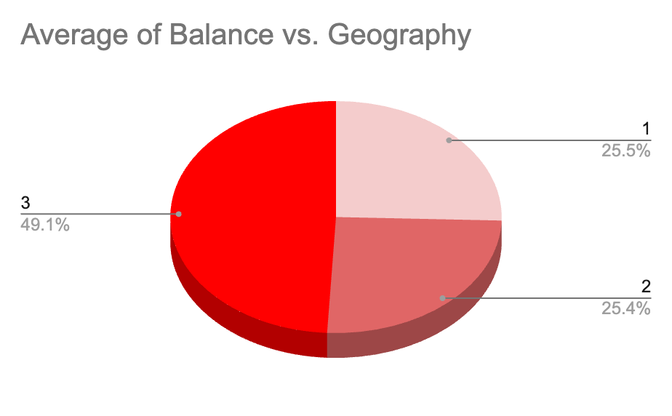
Approach:
- Created pivot table to get the average balance of the customers in different regions.
- Placed geography id in rows and average of balance as values
- Created pie chart to depict the distribution

- Identify the top 5 customers with the highest Estimated Salary in the last quarter of the year. (SQL)
Code:
select *, quarter(str_to_date(bankdoj,'%d/%m/%Y')) as Quarter
from customerinfo
where quarter(str_to_date(bankdoj,'%d/%m/%Y')) = 4
order by estimatedsalary desc
limit 5;
Output:
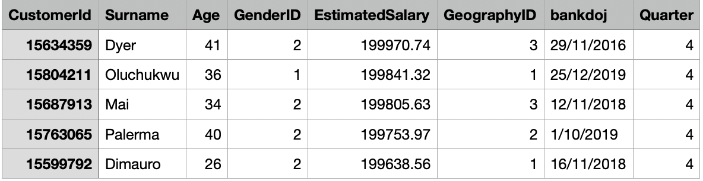
Approach:
- Converted bankdoj to date and used quarter() to find the quarter
- Used where() to filter our the 4th quarter
- Ordered the estimatedsalary in descending to find the employees with top salary
- Used limit to retrieve the top 5 employees

- Calculate the average number of products used by customers who have a credit card. (SQL)
Code:
select b.hascrcard, c.category, avg(b.numofproducts) as averageproducts
from bank_churn b
join creditcard c
on b.hascrcard = c.creditid
group by b.hascrcard, c.category
having c.category = "credit card holder";
Output:
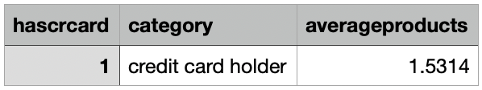
Approach
- Joined bank_churn and creditcard tables
- Found average of products using avg()
- Grouped by category and hascrcard
- Filtered credit card holder using having()

- Determine the churn rate by gender for the most recent year in the dataset.
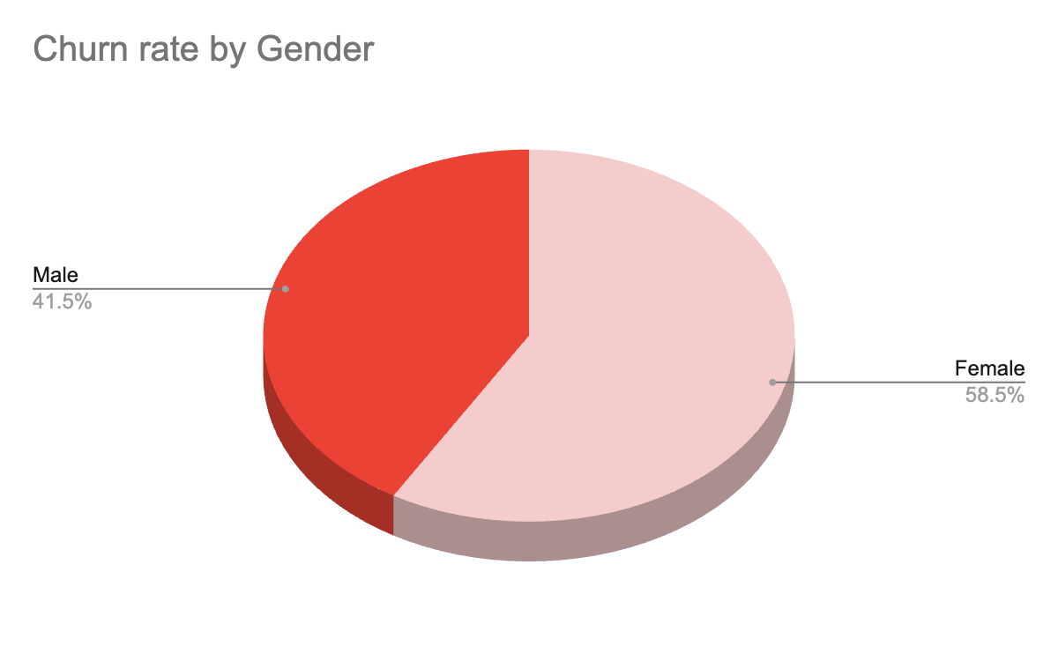
Approach:
- Created pivot table, gender in rows and percentage of total exist_category in values
- Filtered by selecting only “Exit” from exist_category and year “2019”
- Created the visualization using pie chart
- Compare the average credit score of customers who have exited and those who remain. (SQL)
Code:
select e.exitcategory, round(avg(b.creditscore),2) as avg_credit_score
from bank_churn b
join exitcustomer e
on b.exited = e.exitid
group by e.exitcategory;
Output:
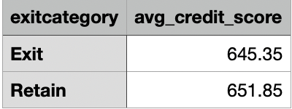
Approach:
- Joined bank_churn and exitcustomer tables
- Grouped by exitcategory and found average of creditscore using avg()
- Rounded the average to 2 decimal places with round()
- Which gender has a higher average estimated salary, and how does it relate to the number of active accounts? (SQL)
Code:
select g.gendercategory, round(avg(c.estimatedsalary),2) as average_estimated_salary, count(a.activecategory) as active_cnt
from bank_churn b
left join customerinfo c
on b.customerid = c.customerid
join gender g
on c.genderid = g.genderid
left join activecustomer a
on b.isactivemember = a.activeid
group by g.gendercategory;
Output:
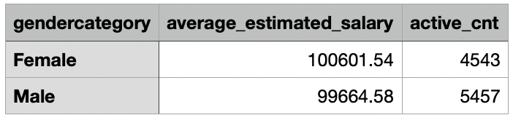
Approach:
- Joined bank_churn, customerinfo, gender and isactivemembers tables
- Grouped by gendercategory to find average estimated salary and active count for each gender using avg() and count()
- Rounded the average to 2 decimal places with round()
- Segment the customers based on their credit score and identify the segment with the highest exit rate. (SQL)
Code:
with segment as (select customerid, exited,
case when creditscore between 800 and 850 then "Excellent"
when creditscore between 740 and 799 then "Very Good"
when creditscore between 670 and 739 then "Good"
else "Poor" end as credit_category
from bank_churn)

select credit_category, round((sum(exited)/count(*))*100,2) as exit_rate
from segment
group by credit_category
order by exit_rate desc;
Output:
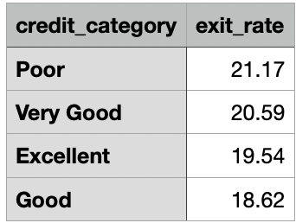
Approach:
- Created a new column credit_category by using case statement to segregate creditscore as excellent, very good, good and poor and wrapped by cte
- Aggregated sum(exit) by total count to get the exit_rate and rounded to 2 decimal places by round()
- Also grouped by credit_category

- Find out which geographic region has the highest number of active customers with a tenure greater than 5 years. (SQL)
Code:
select c.geographyid, count(b.isactivemember) as active_customers_cnt
from customerinfo c
join bank_churn b
on c.customerid = b.customerid
and b.tenure > 5
join activecustomer a
on b.isactivemember = a.activeid
and a.activeid =1
group by c.geographyid
order by active_customers_cnt desc;
Output
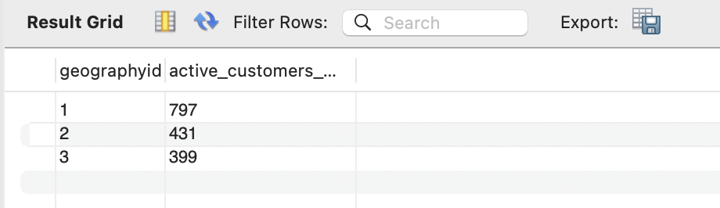
Approach
- Joined tables bank_churn and customerinfo and filtered by tenure greater than 5
- Also joined activecustomers where activeid =1 to retrieve only active customers
- Grouped by geographyid, order by active_customer_cnt desc to get the highest count
- What is the impact of having a credit card on customer churn, based on the available data?
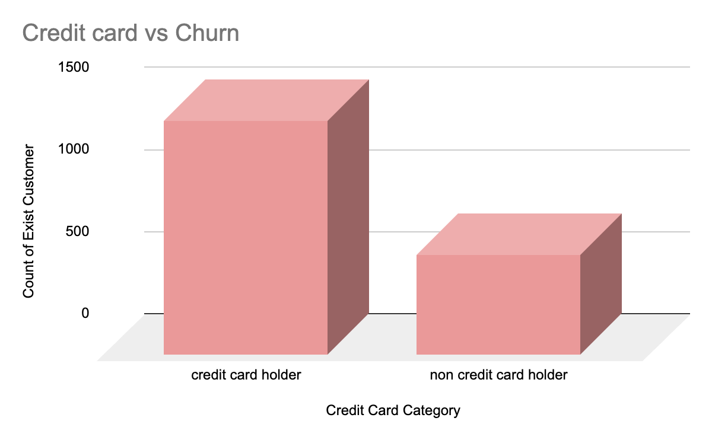
Approach:
- Created pivot table keeping credit_card_category as rows and count of exist_customers in values, filtered by “exit”
- Created bar chart to visualize the difference in the count of churn between credit card holders and non credit card holders
- For customers who have exited, what is the most common number of products they have used?
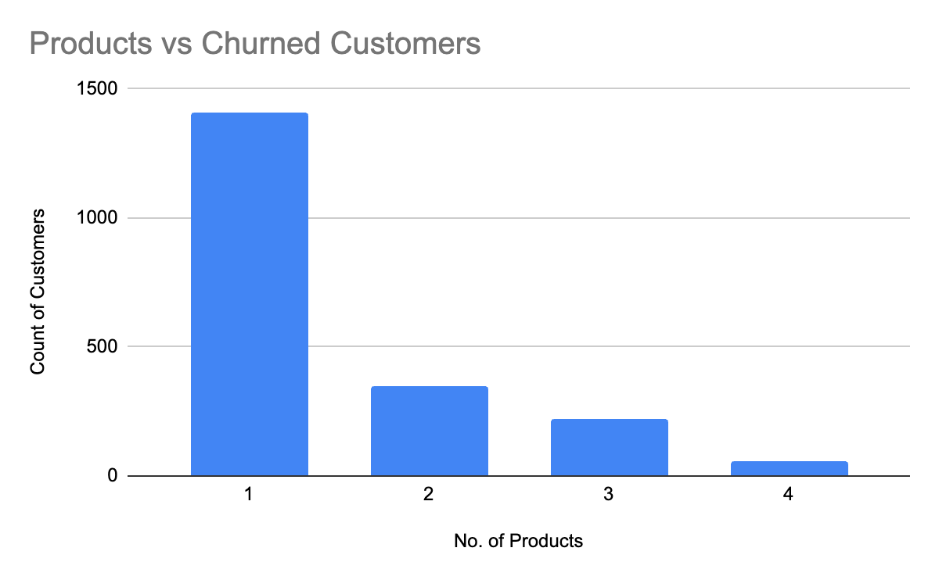
Approach:
- Created pivot table, keeping product count in rows and count of customers in values
- Filtered by “exit”
- Created bar chart to visualize the data
- Examine the trend of customers joining over time and identify any seasonal patterns (yearly or monthly). Prepare the data through SQL and then visualize it.
Code:
-- year wise analysis
select year(str_to_date(bankdoj, "%d/%m/%Y")) as joining_year, count(customerid) as customer_cnt
from customerinfo
group by year(str_to_date(bankdoj, "%d/%m/%Y"))
order by customer_cnt desc;

-- month wise analysis
select date_format(str_to_date(bankdoj, "%d/%m/%Y"), "%M") as joining_month, count(customerid) as customer_cnt
from customerinfo
group by date_format(str_to_date(bankdoj, "%d/%m/%Y"), "%M")
order by customer_cnt desc;
Output
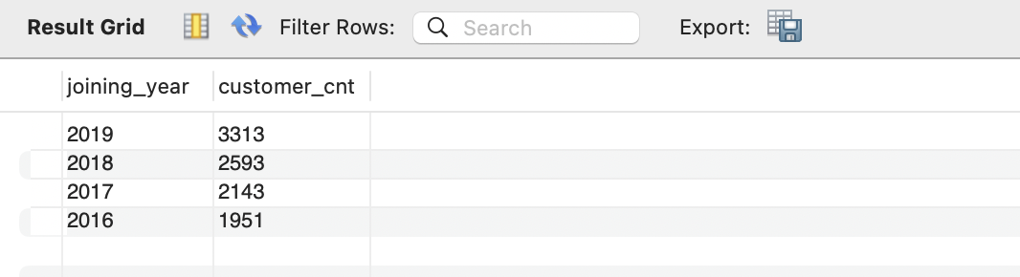
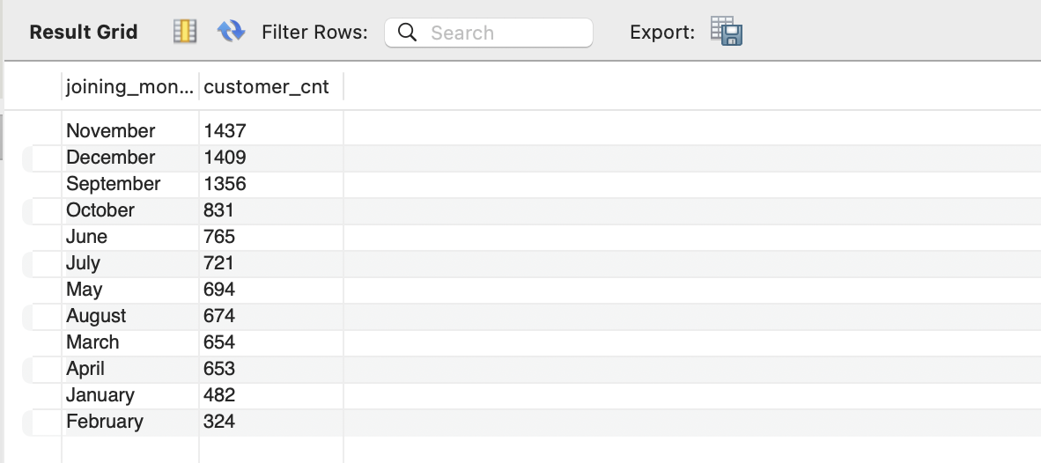
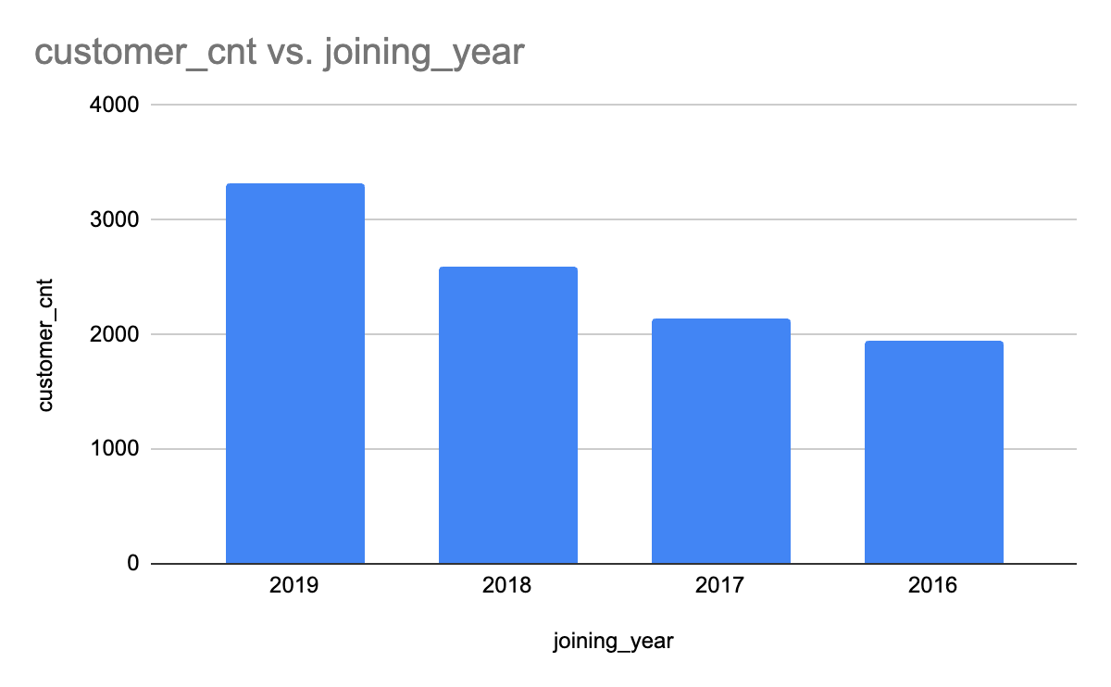
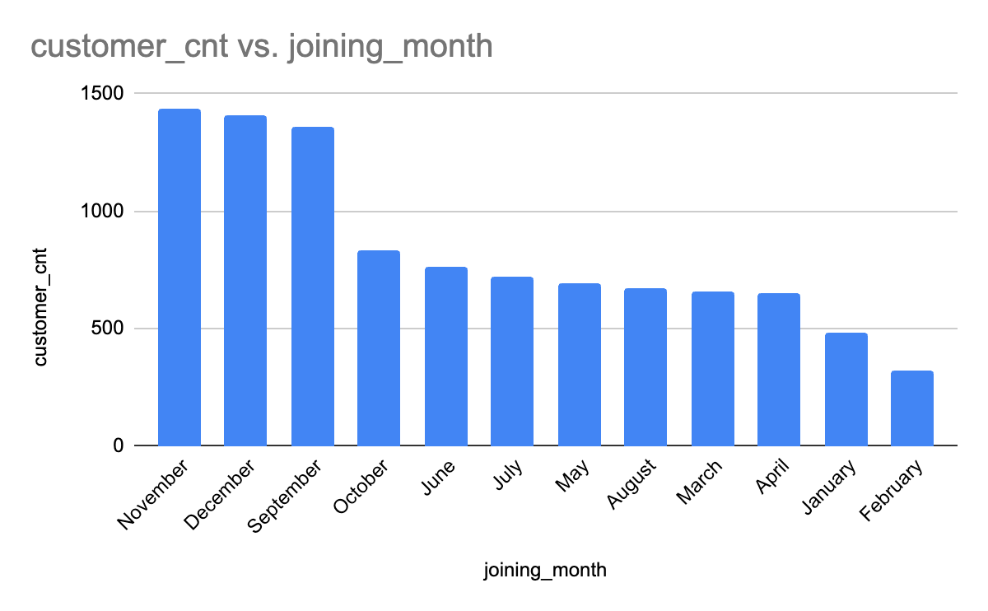

- Analyze the relationship between the number of products and the account balance for customers who have exited.
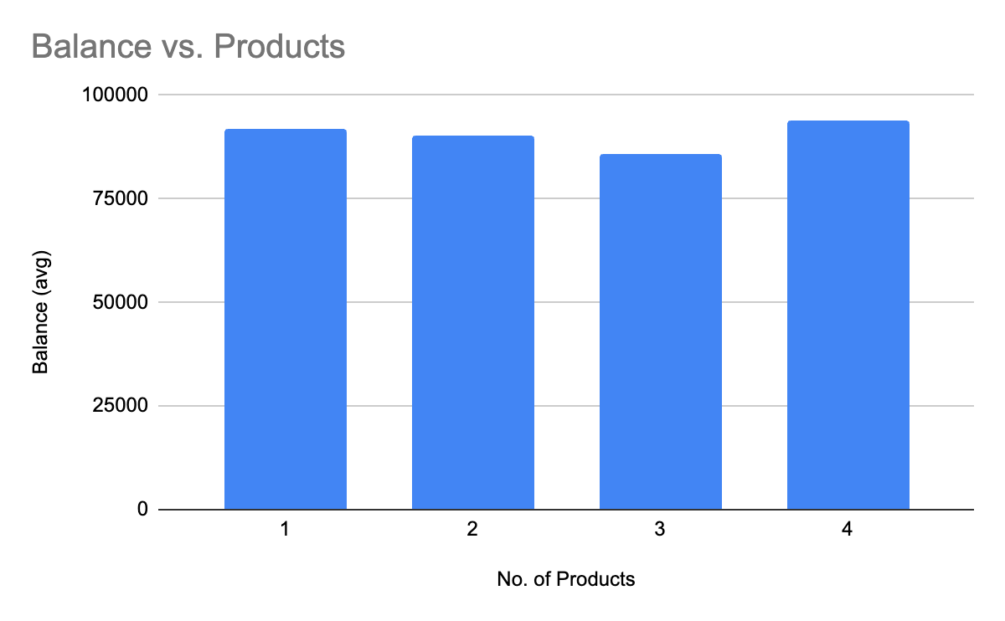
Approach
- Created pivot table with products as rows and average of balance in values
- Filtered by “exit”
- Created bar chart to visualize
- Identify any potential outliers in terms of balance among customers who have remained with the bank.
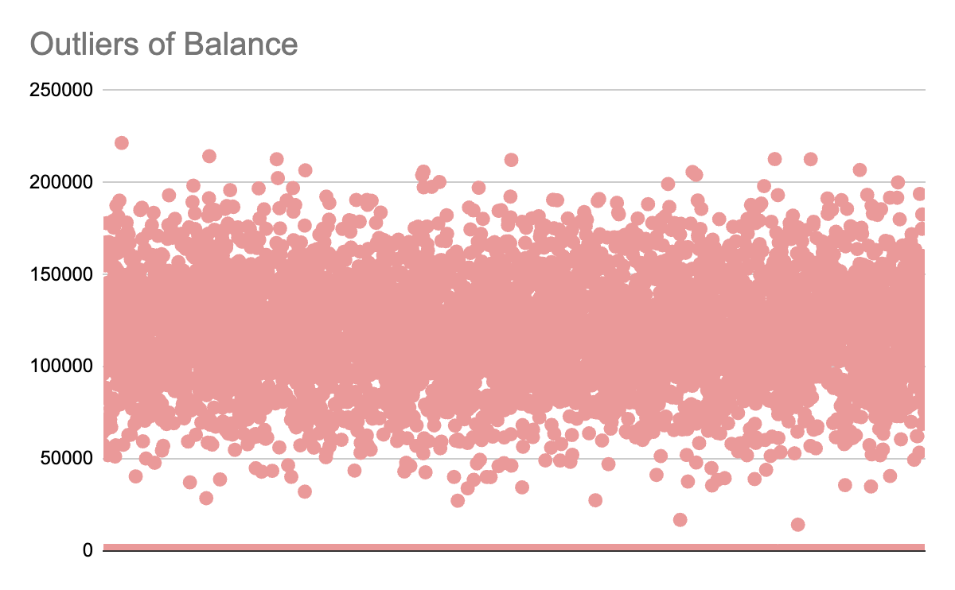
Approach:
- Fetched balance data of the customers and used scatter chart to visualize and detect outliers if any.
- No outliers found
- How many different tables are given in the dataset, out of these tables which table only consists of categorical variables?
- 7 tables are given
- 4 tables consist only categorical variables
- Using SQL, write a query to find out the gender-wise average income of males and females in each geography id. Also, rank the gender according to the average value. (SQL)
Code:
with calculated as (select g.gendercategory, round(avg(c.estimatedsalary),2) as average_estimated_salary, c.geographyid
from customerinfo c
join gender g
on c.genderid = g.genderid
group by g.gendercategory,c.geographyid)

select *, rank() over(partition by geographyid order by average_estimated_salary desc) as rnk
from calculated;
Output
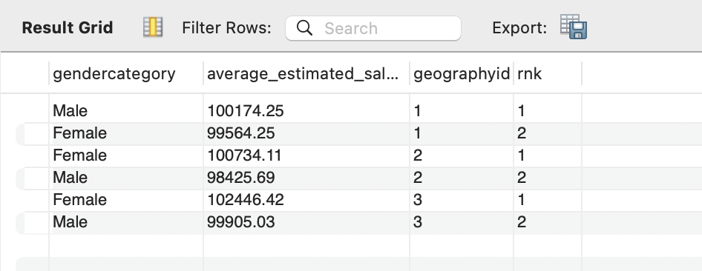
Approach;
- Calculated average estimated salary using avg(). Rounded with round() by joining customerifo and gender tables
- Grouped by gender and geography to get the average for each gender of different geography
- Used window function to rank the estimated salary of each geography
- Using SQL, write a query to find out the average tenure of the people who have exited in each age bracket (18-30, 30-50, 50+).
Code:
with ageseg as (select customerid,
case when age between 18 and 29 then "18-29"
when age between 30 and 49 then "30-49"
else "50+" end as age_bracket
from customerinfo)

select a.age_bracket, round(avg(b.tenure),2) as avgtenure
from ageseg a
join bank_churn b
on a.customerid = b.customerid
and b.exited = 1
group by a.age_bracket;

Output:
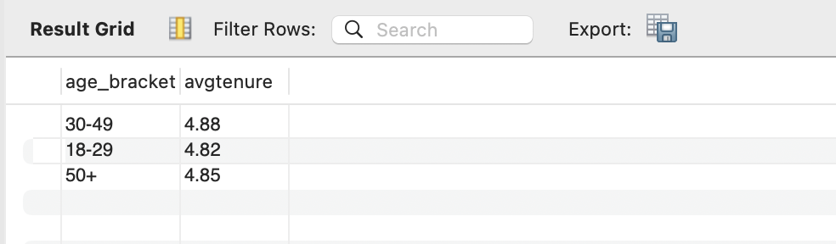
Approach:

- Used case statement to create age brackets and wrapped in cte
- Joined the cte with bank_churn table and filtered only exited customers.
- Grouped by age bracket to find the average tenure and rounded it.

- Is there any direct correlation between salary and the balance of the customers? And is it different for people who have exited or not?
- No correlation found since the correl value is close to zero
Exited | -0.01254045473
Retain | 0.01719857062

Approach
- Formulas used to get the correlation between salary and balance
- Exited - =CORREL(filter(Bank_Churn!E2:E10001,Bank_Churn!J2:J10001=1),filter(Bank_Churn!O2:O10001,Bank_Churn!J2:J10001=1))
- Retain- =CORREL(filter(Bank_Churn!E2:E10001,Bank_Churn!J2:J10001=0),filter(Bank_Churn!O2:O10001,Bank_Churn!J2:J10001=0))
- Is there any correlation between the salary and the Credit score of customers?
- No correlation found since the correl value is close to zero
- -0.001384292868
- Approach
- Formulas used to get the correlation between salary and balance
- =CORREL(Bank_Churn!O2:O10001,Bank_Churn!C2:C10001)
- Rank each bucket of credit score as per the number of customers who have churned the bank.
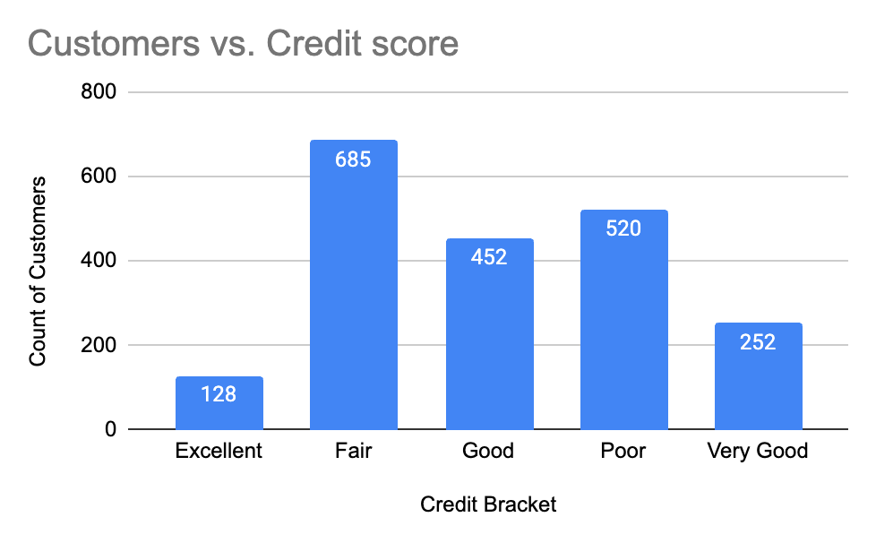
Approach
- Created credit bracket using IF formula: =IF(C2>=800, "Excellent",If(C2>=740,"Very Good", If(C2>=670, "Good", If(C2>=580,"Fair", "Poor"))))
- Created pivot table keeping credit bracket in rows and count of customer_id in values, filtered by “exit”
- Bar chart is used to visualize
- According to the age buckets find the number of customers who have a credit card. Also retrieve those buckets that have lesser than average number of credit cards per bucket.
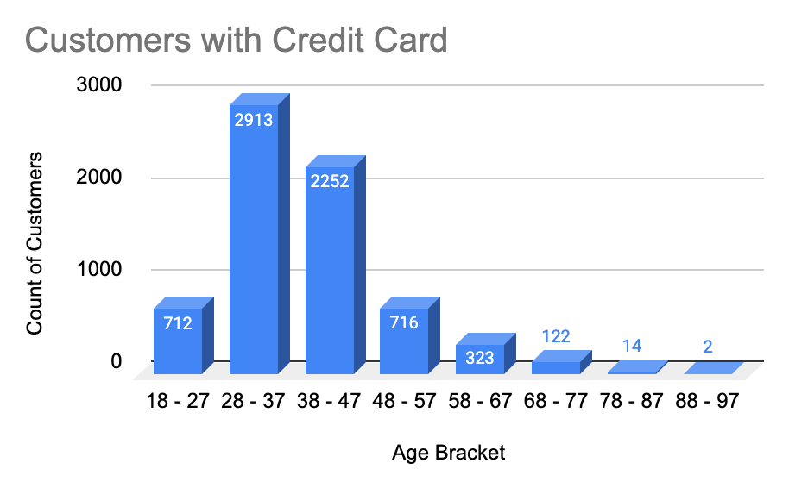
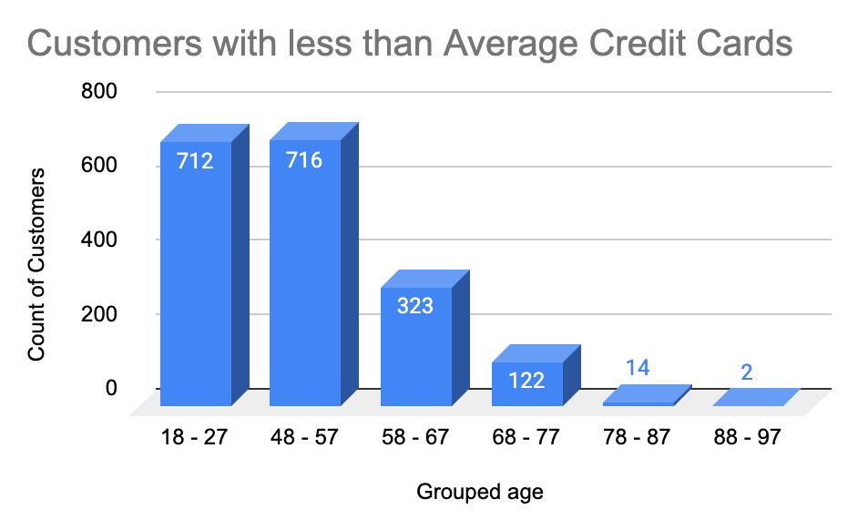
Approach
- Created pivot table with age and credit card columns and filtered with “credit card holder”
- Grouped the age to age brackets using group pivot
- Find the average no. of credit card using formula =IF(B22< AVERAGE($B$7:$B$14),"Low","High") to find the buckets that have lesser than average number of credit cards per bucket
- Created bar chart for visualization
- Rank the Locations as per the number of people who have churned the bank and average balance of the customers.
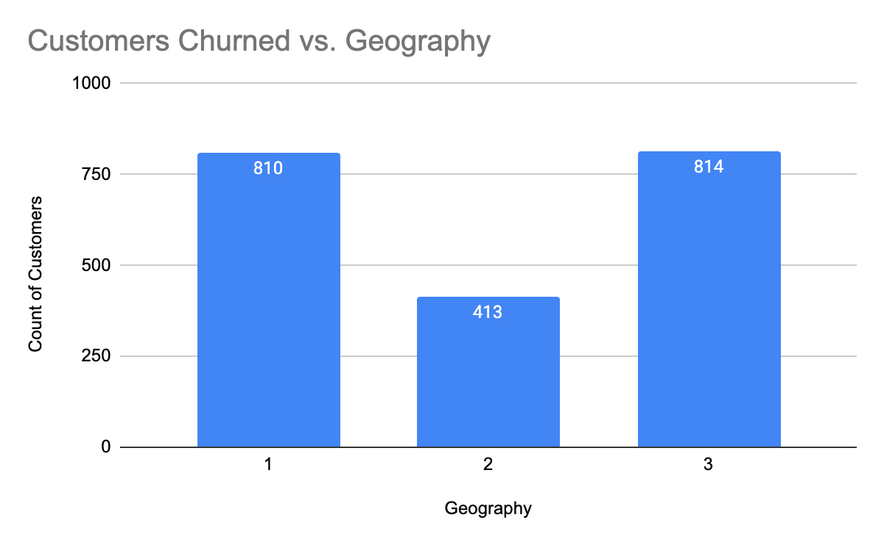
Approach
- Created pivot with geography_id in rows and count of customers and average of balance as values.
- Filtered by “exit”
- As we can see that the “CustomerInfo” table has the CustomerID and Surname, now if we have to join it with a table where the primary key is also a combination of CustomerID and Surname, come up with a column where the format is “CustomerID_Surname”.

CustomerId | Surname | CustomerID_Surname
15634602 | Hargrave | 15634602_Hargrave
15647311 | Hill | 15647311_Hill
15619304 | Onio | 15619304_Onio
15701354 | Boni | 15701354_Boni
15737888 | Mitchell | 15737888_Mitchell
15574012 | Chu | 15574012_Chu

Approach
- Used formula =CONCATENATE(A5&"_"&B5)
- Without using “Join”, can we get the “ExitCategory” from ExitCustomers table to Bank_Churn table? If yes do this using SQL.
Code:
select *, (select e.exitcategory from exitcustomer e where e.exitid =b.exited) as ExitCategory
from bank_churn b;
Output
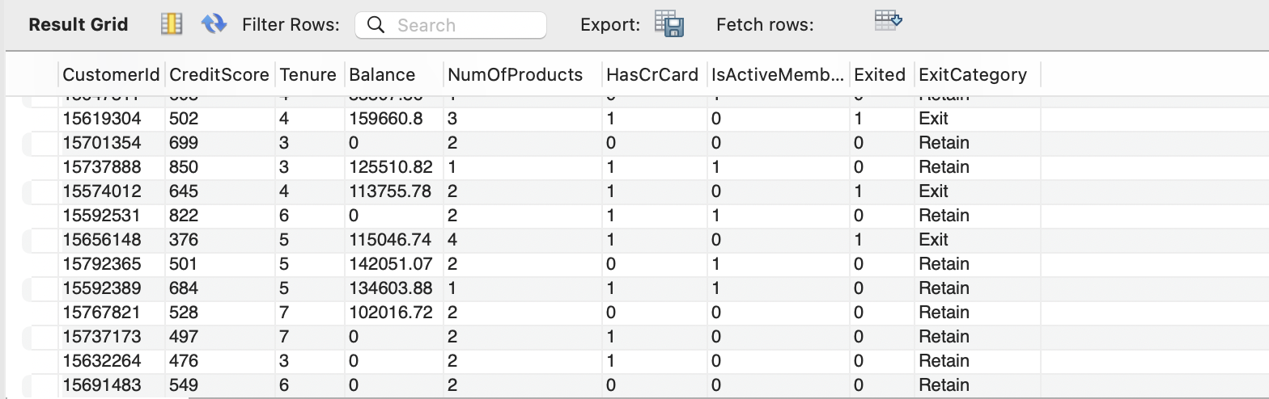
Approach
- Used subquery in the select statement to create a new column ExitCategory and fetched exitcategory from exitcustomer
- Were there any missing values in the data, using which tool did you replace them and what are the ways to handle them?
- No missing values
Approach
- Count blanks to find the missing values
- Methods to handle missing values : find and replace, isblank()

25. Write the query to get the customer IDs, their last name, and whether they are
active or not for the customers whose surname ends with “on”.
Code:
select c.customerid, c.surname, b.isactivemember
from customerinfo c
join bank_churn b
on c.customerid = b.customerid
where surname like "%on";
Output:
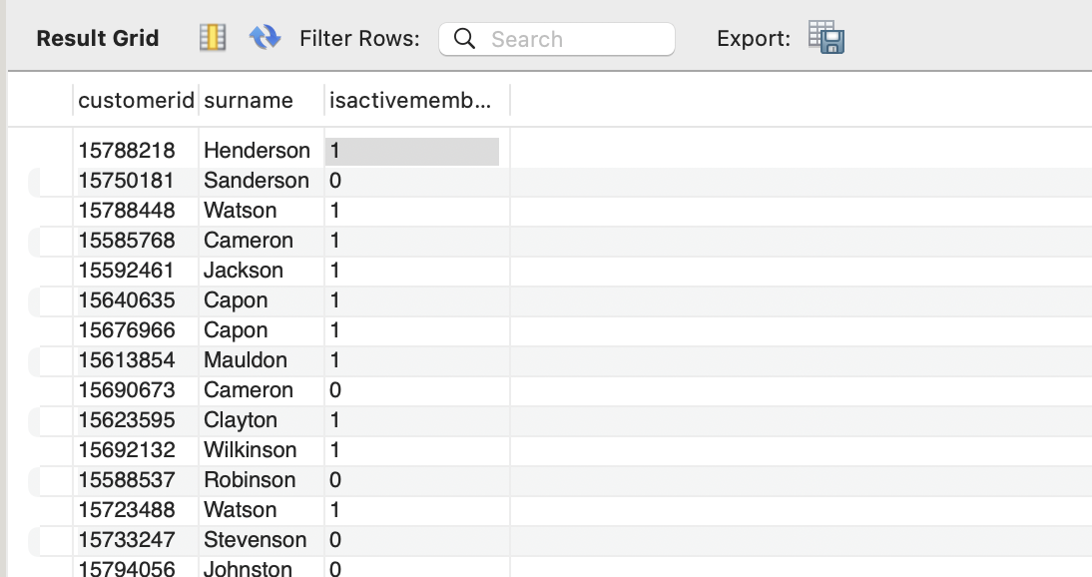
Approach
- Joined tables customerinfo and bank_churn
- Filtered using wildcard like “%on”
- Can you observe any data disrupency in the Customer’s data? As a hint it’s present in the IsActiveMember and Exited columns. One more point to consider is that the data in the Exited Column is absolutely correct and accurate.
- Yes. The exited customers are shown active under the active member column.
Approach
- Used formula =IF(J2=1,0,H2) to update the active member column
- When J2 (exited) is true then active_member should be false.

Subjective Question:

- Customer Behavior Analysis: What patterns can be observed in the spending habits of long-term customers compared to new customers, and what might these patterns suggest about customer loyalty?
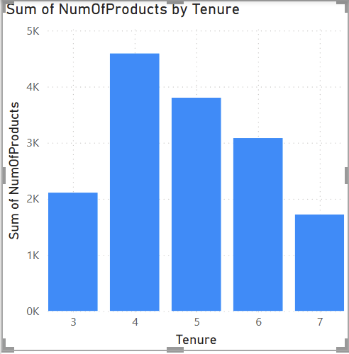
Insight:
- Long term customers are not spending much compared to the new customers
- Long term customers might not be aware of the new services due to the lack of campaign reach
- Customers are purchasing product once they feel trustworthy or comfortable with the bank

Recommendation:
- Long term customers are loyal customers, marketing team has to do campaign to re-introduce the services to them
- Customer service calls has to be done once in 3 months
- Engage with the customers to make them feel confident with the banking

- Product Affinity Study: Which bank products or services are most commonly used together, and how might this influence cross-selling strategies?
- Credit cards and debit cards are used together.

- Geographic Market Trends: How do economic indicators in different geographic regions correlate with the number of active accounts and customer churn rates?
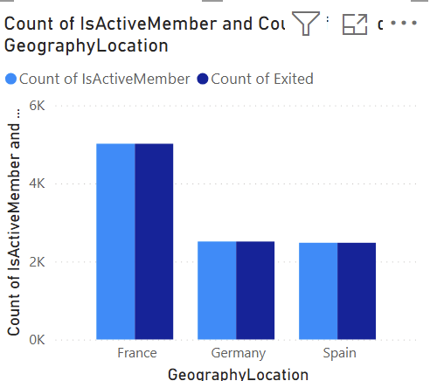
Insights:
- Active members and exited members are equal in all countries.
- Population, employment factors can affect the active accounts and churn rates

- Risk Management Assessment: Based on customer profiles, which demographic segments appear to pose the highest financial risk to the bank, and why?
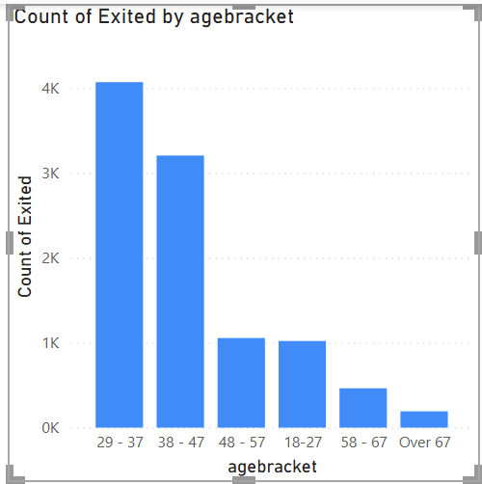
Approach
Created by adding new column, agebracket = IF([Age] < 28, "18-27",IF([Age] <= 37, "29 - 37",IF([Age] <= 47, "38 - 47",IF([Age] <= 57, "48 - 57",IF([Age] <= 67, "58 - 67", "Over 67")))))
Insights:
- Exit rates are high in 29-47 age brackets
- These groups might be married people with kids
Recommendations:
- Incorporate services apt for married couples and their kids

- Customer Tenure Value Forecast: How would you use the available data to model and predict the lifetime (tenure) value in the bank of different customer segments?
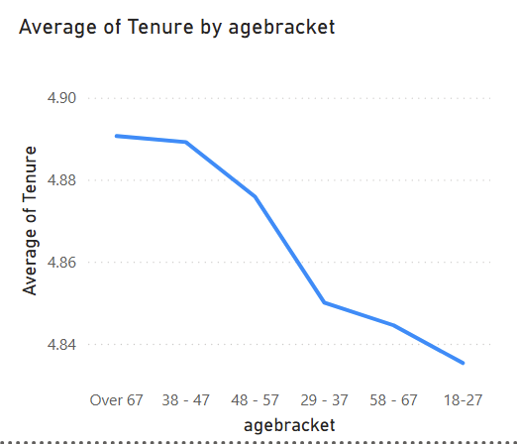
Approach:
- Plotting a line chart of age bracket and tenure can use to analyse the tenure value

- Marketing Campaign Effectiveness: How could you assess the impact of marketing campaigns on customer retention and acquisition within the dataset? What extra information would you need to solve this?
- Customer Engagement data - sudden increase in the engagement might be impact of marketing campaign
- Purchase history - Change in the purchasing behaviour
- Marketing data - Required to analyse the impact

- Customer Exit Reasons Exploration: Can you identify common characteristics or trends among customers who have exited that could explain their reasons for leaving?
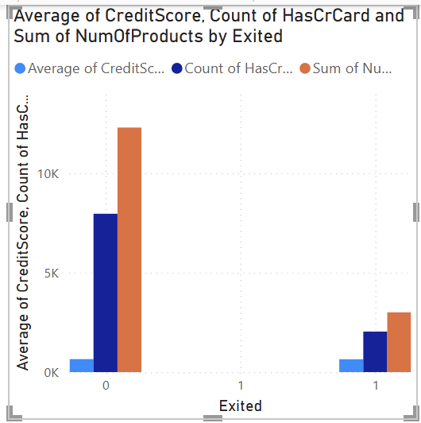
Insights:
- Credit score have no much influence on exiting customers behavior
- Exit Customers doesn’t prefer credit card nor purchase much products
- Age group of 29-37 are more intended to exit
- France has shown high exit rate

- Are 'Tenure', 'NumOfProducts', 'IsActiveMember', and 'EstimatedSalary' important for predicting if a customer will leave the bank?
- Yes.

- Utilize SQL queries to segment customers based on demographics and account details.
Code:
with ageseg as (select customerid,
case when age between 18 and 29 then "18-29"
when age between 30 and 49 then "30-49"
else "50+" end as age_bracket
from customerinfo)

select a.age_bracket, round(avg(b.tenure),2) as avgtenure
from ageseg a
join bank_churn b
on a.customerid = b.customerid
and b.exited = 1
group by a.age_bracket;

Output:

- How can we create a conditional formatting setup to visually highlight customers at risk of churn and to evaluate the impact of credit card rewards on customer retention?
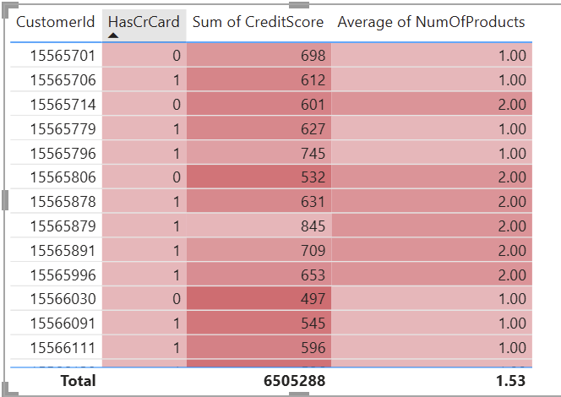
- What is the current churn rate per year and overall as well in the bank? Can you suggest some insights to the bank about which kind of customers are more likely to churn and what different strategies can be used to decrease the churn rate?
- Customers who opt out of credit cards have a high chance of churning.
- Also the customers who purchase less products.

- Create a dashboard incorporating all the KPIs and visualization-related metrics. Use a slicer in order to assist in selection in the dashboard.
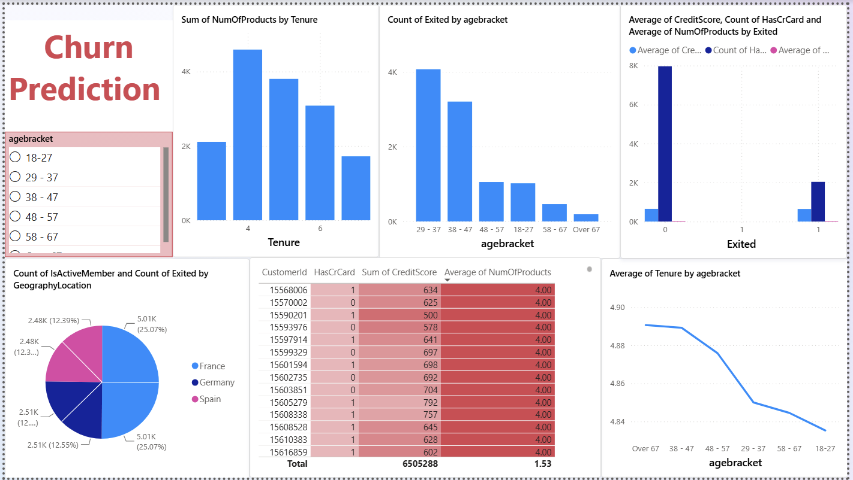
- How would you approach this problem, if the objective and subjective questions weren't given?
- Find churn pattern by analysing the data
- Incorporate plans to retain the customers

- In the “Bank_Churn” table how can you modify the name of the “HasCrCard” column to “Has_creditcard”?
- Go to data section, click on the 3 dots of the “HasCrCard” column and click rename option

